Topic 4.1

KINETICS

Rate equations
Determining orders of reaction
Explaining orders of reaction
Effect of changing conditions on the rate constant

RATE EQUATIONS

The relationship between the rate of a chemical reaction and the concentration of the reactants is shown by the rate equation of the reaction.

Consider the reaction A + 3B → 2C + 4D

The rate of this chemical reaction is given by the equation

Rate = k[A]^{x}[B]^{y}

[A] is the concentration of A, and [B] is the concentration of B.

x and y are the orders of reaction with respect to A and B respectively.

The order of reaction with respect to a given reactant is the power of that reactant's concentration in the rate equation.

The sum of these powers, in this case x + y, is known as the overall order of reaction:

The overall order of reaction is the sum of the powers of the reactant concentrations in the rate equation

k is the rate constant of the reaction.

The rate constant is the constant of proportionality in the rate equation.

- Rate of reaction

During a chemical reaction, the concentration of the reactants decreases and the concentration of the products increases.

variation of concentrations of reactants and products with time
reactants
products
time
concentration

The rate of a reaction is the decrease in concentration of reactants per unit time, or the increase in concentration of products per unit time.

The units of rate of reaction are moldm⁻³s⁻¹.
DETERMINING ORDERS OF REACTION

The orders of reaction with respect to each reactant in the reaction can be determined by carrying out the reaction with various different initial concentrations and measuring the change in initial rate of reaction. The orders of reaction can be determined arithmetically or graphically.

If the order of reaction with respect to one reactant is being determined, the concentration of one reactant only should change; the others should remain constant so that the change in rate can be attributed to the change in concentration of that reactant alone.

If the overall order is being determined, the concentration of all reactants should change by the same factor.

1. The arithmetic method (used in Unit 4 examinations)

(change in concentration)^{order of reaction} = change in rate

If the reaction is first order, then if the concentration doubles the rate will also double. If the concentration triples the rate will also triple, etc.

If the reaction is second order, then if the concentration doubles the rate will quadruple. If the concentration triples the rate will increase ninefold, etc.

If the reaction is zero order, then the change in concentration will have no effect on the rate of reaction.

Example 1

Consider the reaction RX + OH⁻ → ROH + X⁻
The following rate data were obtained at constant temperature:

Initial concentration of RX/ moldm⁻³ | Initial concentration of OH/ moldm⁻³ | Initial rate/ moldm⁻³ s⁻¹
0.01 | 0.04 | 8 x 10⁻³
0.01 | 0.02 | 4 x 10⁻³
0.005 | 0.04 | 4 x 10⁻³

From expt 2 to expt 1, the concentration of hydroxide ions doubles and the concentration of RX is unchanged. The rate also doubles, so the order of reaction with respect to OH⁻ is 1.

From expt 3 to expt 1, the concentration of RX doubles and the concentration of hydroxide ions is unchanged. The rate also doubles, so the order of reaction with respect to RX is also 1.

The rate equation can thus be written as follows: rate = k[RX][OH⁻]

Having deduced the rate equation, the rate constant can be calculated using the data in one of the experiments.

Eg in expt 1, k = rate/([RX][OH⁻]) = 8 x 10⁻³/(0.04 x 0.01) = 20 mol⁻¹dm³s⁻¹.

Example 2

Consider the reaction PCl₃ + Cl₂ → PCl₅
The following rate data were obtained at constant temperature:

Initial concentration of PCl₃/ moldm⁻³ | Initial concentration of Cl₂/ moldm⁻³ | Initial rate/ moldm⁻³ s⁻¹
0.2 | 0.1 | 0.0004
0.4 | 0.1 | 0.0008
0.8 | 0.2 | 0.0064

From expt 1 to expt 2, the concentration of PCl₃ doubles and the concentration of Cl₂ is unchanged. The rate also doubles, so the order of reaction with respect to PCl₃ is 1.

From experiment 2 to experiment 3, the concentration of both reactants doubles. The rate increases eightfold, so the overall order of reaction is three.

The order of reaction with respect to chlorine is therefore 3 – 1 = 2.

The rate equation can thus be written as follows: rate = k[PCl][Cl]²

So k = rate/[PCl₃][Cl₂]² = 0.0004/(0.2 x 0.1²) = 0.2 mol⁻²dm⁶s⁻¹
2. Graphical method (used in practicals)

If the concentrations in the different experiments are not simple whole number ratios of each other, it is not easy to compare the concentrations and rates. The order of reaction with respect to each reactant can be deduced by plotting a graph of concentration vs initial rate.

- first-order reactions

If Rate = k[A], then a plot of initial rate against initial concentration will be a staight line through the origin of gradient k:

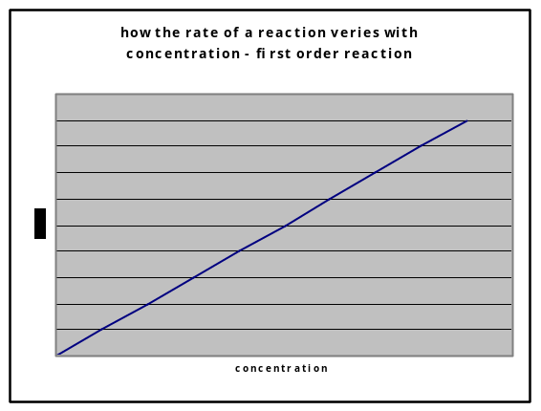

- second-order reactions

If rate = k[A] ², then a plot of initial rate against initial concentration will be a curve through the origin.

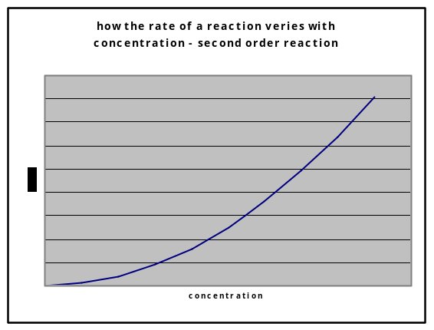

- zero order reactions

If rate = k, then a plot of initial rate against initial concentration will be a horizontal line:

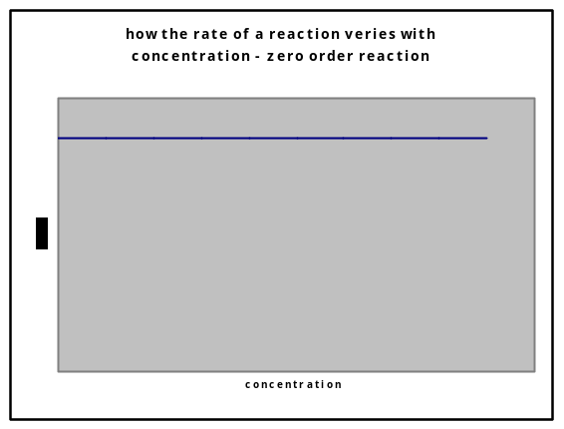

An even better method is to plot log (rate of reaction) against log (concentration). This should always give a straight line, the gradient of which is the order of reaction.

3. Measuring initial rates of reaction

In some reactions, it is not easy to measure the rate of reaction directly, and easier to mention the time taken for a particular stage in the reaction to be reached.

Since rate is the change in concentration per unit time, it follows that the rate is inversely proportional to time taken. A graph of 1/t against initial concentration will give curves like those shown above.

Examples of such measurements could be:

- time taken for fixed amount of gas to be produced

- time taken for absorbance to change by a certain amount

- use of a clock reaction: the appearance of a certain coloured product is delayed by adding a fixed amount of another species.
Eg S₂O₈²⁻(aq) + 2I⁻(aq) → 2SO₄²⁻(aq) + I₂(aq)
Iodine is produced in this reaction. If starch was added to the original mixture, a blue-black colour would appear immediately. However if a fixed amount (ie 0.02 moles) of sodium thiosulphate is also added to the mixture, it reacts with the iodine and a blue-black colour is only seen when all the thiosulphate has been used up.
It is possible to measure the time taken for the blue-black colour to appear.
EXPLAINING ORDERS OF REACTION

The orders of reaction for a chemical equation are not always the same as the reaction coefficients:

Eg the reaction NO₂ + H₂ → NO + H₂O has the following rate equation:
rate = k[NO₂]²
It is therefore not possible to predict the rate equation of a reaction simply by looking at the reaction coefficients.

Many reactions consist of a series of different steps, some of which are slow and some of which are very fast.
It is the slowest step in a chemical reaction which determines how fast a reaction is. For this reason the slowest step in a chemical reaction is called the rate-determining step. Changing the rate of this step will affect the overall rate of reaction; changing the rate of fast steps won’t.

Eg consider the reaction NO₂ + H₂ → NO + H₂O
This reaction happens in two steps:
Step 1: NO₂ + NO₂ → NO₃ + NO this step is slow
Step 2: NO₃ + H₂ → NO₂ + H₂O this step is fast
Step 1 is the slowest step and is therefore the rate-determining step. This involves two molecules of NO₂, and so doubling the concentration of NO₂ will make collisions in this step four times more likely. So the reaction is second order with respect to NO₂. H₂ is not involved in this step; it is only involved in the second, fast step. Changing the concentration of H₂ therefore has no effect on the rate of reaction, and the reaction is zero order with respect to H₂.

The rate equation of a chemical reaction is determined by the number of each species involved in the rate-determining step of that reaction.

EFFECT OF CHANGING CONDITIONS ON THE RATE CONSTANT

The rate equation shows the relationship between the concentration of reactants and the rate of reaction.

If the concentration of one of the reactants increases, the rate of reaction will also increase, the rate constant, k will not change.

If the pressure increases, the concentration of all the reactants will increase and so the rate of reaction will also increases. Again the rate constant will not change.

The rate constant k is thus independent of concentration and pressure.

If the temperature increases, however, or a catalyst is added, the rate of reaction increases without a change in concentration, and so it must be the rate constant, k, that is changing.

The rate constant k thus varies with temperature, and is also affected by the addition of a catalyst.

If the temperature is increased, the rate constant k also increases.

If the temperature is decreased, the rate constant k will decrease.

If the concentration or pressure is changed at constant temperature, the rate constant will not change.

